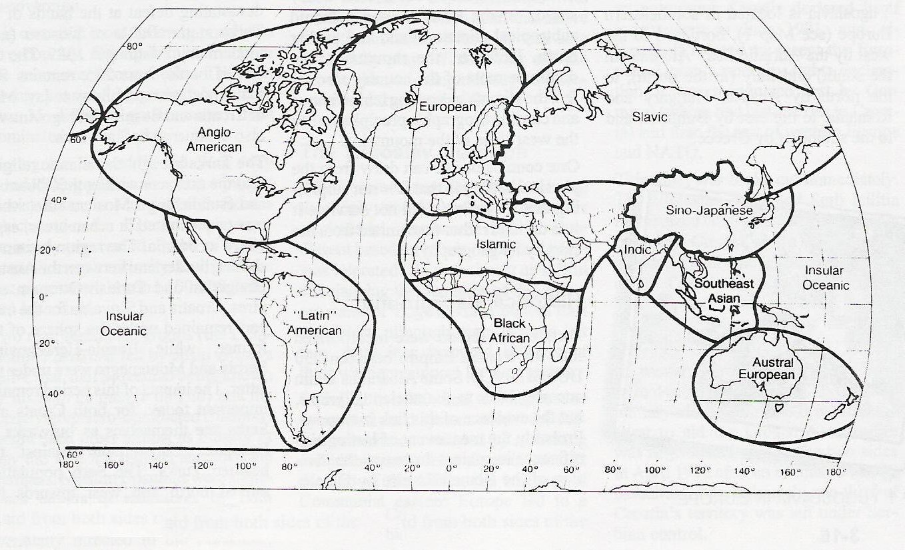

**Cultural Realms**

**Realm = many regions which share cultural traits**

Sino = relating to China

Also called Sub Saharan Africa

Insular = relating to the islands

Anglo = relating to England